**Group Presentation**

**Group Number 5**

**Members:** 1. -Tarandeep Kaur

2. Bao-Viet Ho

3. Ali Riza Sevgili

4. Ivan Shandra

5. Claudia Suarez Socorro

**Professor:** Tevin Apenteng

April 4, 2024

**User Story: Loyalty Program Enrollment**

**Importance of our User Story and Why we chose it?**

Imagine moving into a store in which you're no longer just every other client, but a valued member of their community. That's the essence of loyalty packages. They're now not simply schemes or tactics; they're a logo's way of saying, "We see you, we recognize you, and we need you again." Especially inside the world of dad-up stores—the ones with fleeting, momentary purchasing reviews—loyalty packages do something quite superb. They transform a temporary encounter into a long-lasting court, making the brand linger in your thoughts long after the shop has vanished.

So, as we delve deeper into the arena of pop-up retail and loyalty packages, recollect, that it's all approximately building bridges. This creation units the degree for a deeper exploration of how these packages now not only retain customers but additionally remodel them into the lifeblood of the emblem, making sure they go back time and time again.

**The Essence of Customer Loyalty:**

In the bustling world of retail, customer loyalty isn't just a nice-to-have; it's a treasure trove that brands earnestly seek. It's about turning casual shoppers into steadfast allies, creating a community where every purchase feels like a mutual success. Let's unravel the layers of why nurturing customer :

* Imagine a world where customers don't just visit once but become regulars, each visit adding more to the narrative they share with your brand. That's the power of CLV. It's about the long game, where loyal customers not only visit more but also spend more, turning each transaction into a chapter of a rewarding mutual story.
* Finding new customers is an adventure—a costly one. Here's where loyalty steps in to ease the journey, making every retained customer a beacon that attracts others. It's about creating a family of customers who, through their advocacy and word-of-mouth, become your most effective marketers, reducing the need to constantly seek new patrons.
* Regular customers aren't just frequent visitors; they're also more likely to explore and buy more. With loyalty programs offering tailored rewards and incentives, customers have a personalized map that encourages them to discover and purchase more, making each visit a treasure hunt with rewards that feel personal and satisfying.
* Loyalty programs open a channel of communication, turning every feedback opportunity into a moment of connection and improvement. This ongoing dialogue not only helps you refine your offerings but also solidifies trust, making customers feel heard and valued, a fundamental aspect of deepening loyalty.

Every step, from enrolling in a program to becoming a brand advocate, is a step toward a more interconnected and mutually rewarding relationship. These include,

**Customer Enrollment Request:** This initial step involves the customer providing necessary information (name, email, and phone number) to enroll in the loyalty program. This forms the core of the user story and is the first step in the customer loyalty creation process. The customer's request to join the loyalty program is a critical resource for the business to expand its customer database and manage customer relationships.

**Terms and Conditions:** It is required for the customer to view and accept the program's terms and conditions. This step is crucial in maintaining the transparency of the business and securing customer trust. Clearly defined terms increase customer satisfaction and minimize the business's legal liabilities.

**Unique Identity Creation:** Once the customer consents, a unique loyalty program identity is created. This unique identifier is used to personalize customer interactions and track loyalty points or rewards. Offers tailored to the customer enhance the effectiveness of the loyalty program, encouraging repeat purchases.

**Enrollment Confirmation and Successful Registration Information:** The successful completion of customer registration is a concrete indication of the customer's loyalty to the business. This step supports the business's strategy to materially increase customer loyalty and encourage repeat sales.

These processes demonstrate that the "Enrollment in Loyalty Program" user story is a significant component that enriches the customer experience, strengthens business-customer relationships and adds value to the business's marketing strategies.

**User Story: Loyalty Program Enrollment**

As the owner of the retail "pop-up" store, I want to implement a loyalty program to incentivize customer loyalty and increase repeat purchases.

Acceptance Criteria:

1. Customer provides necessary information (name, email, phone) for enrollment.
2. Clear presentation and explicit agreement to terms and conditions.
3. Generation and storage of unique loyalty program ID upon successful enrollment.

**Class Diagram**

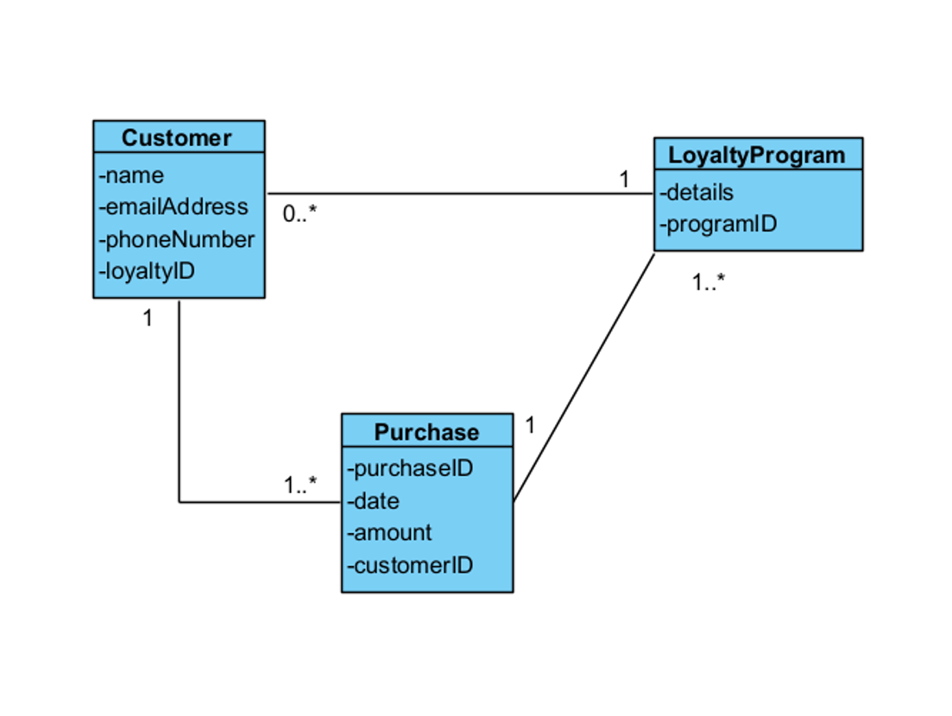

**Use Case Description 1:**

|  |  |  |  |
| --- | --- | --- | --- |
| Use Case Name | Enroll in Loyalty Program | | |
| Triggering Event | Customer wishes to enroll in the loyalty program. | | |
| Brief Description | Allows a customer to enroll in the retail "pop-up" store's loyalty program. | | |
| Actors | Customer | | |
| Related Use Cases |  | | |
| Preconditions | Customer has accessed the loyalty program enrollment section of the application. | | |
| Post Conditions | Customer is successfully enrolled and can be queried if required. | | |
| Flow of activities | Actor | | System |
|  | 1. | Requests to enroll in the loyalty program. | Prompts the customer to provide necessary information -  full name, email address, and phone number |
|  | 2. | Enters full name, email address and Phone Number. | Verifies full name, email address and Phone Number have been entered. Presents the terms and conditions of the loyalty program to the customer and prompts to agree. |
|  | 3. | Reads and agrees to the terms and conditions. | Verifies if Agree Radio Button was checked.  Generates a unique loyalty program ID.  Prompts to save and exit. |
|  | 4. | Chooses to exit and save | Saves the data.  Displays confirmation of successful enrollment.  Returns to the main menu. |
| Exception Conditions | * Customer declines to provide required information. * Customer declines to agree to the terms and conditions of the loyalty program. | | |

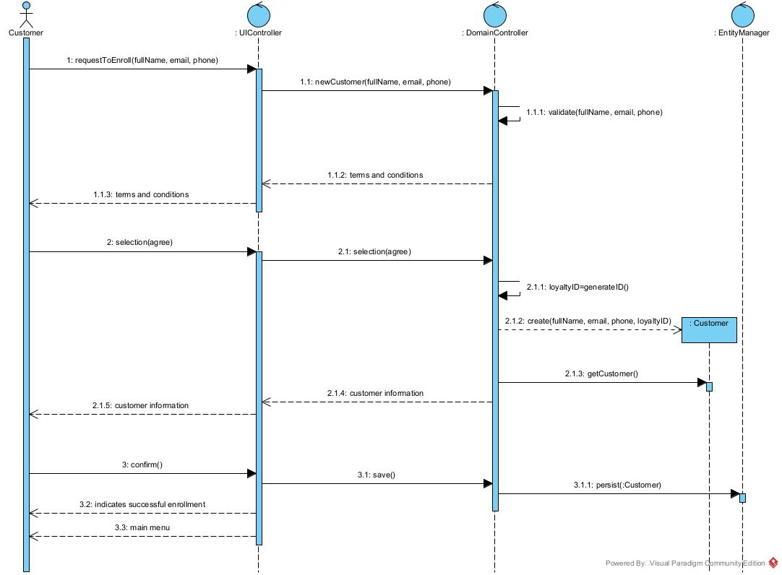

**Use Case Description 2:**

|  |  |  |  |
| --- | --- | --- | --- |
| Use Case Name | Query Loyalty Program Enrollment | | |
| Triggering Event | Owner wishes to view enrolled customers in the loyalty program. | | |
| Brief Description | Allows the business owner to query and view enrolled customers in the loyalty program. | | |
| Actors | Owner | | |
| Related Use Cases |  | | |
| Preconditions | Owner has opened the Main Menu. | | |
| Post Conditions | All customers enrolled in the loyalty program get displayed. | | |
| Flow of activities | Actor | | System |
|  | 1. | Requests to query enrolled customers in the loyalty program. | Displays a list of enrolled customers, including their names, contact information, and loyalty program IDs. |
|  | 2. | Chooses to cancel. | Returns to the main menu. |
| Exception Conditions | Owner chooses to cancel querying loyalty program customers. | | |

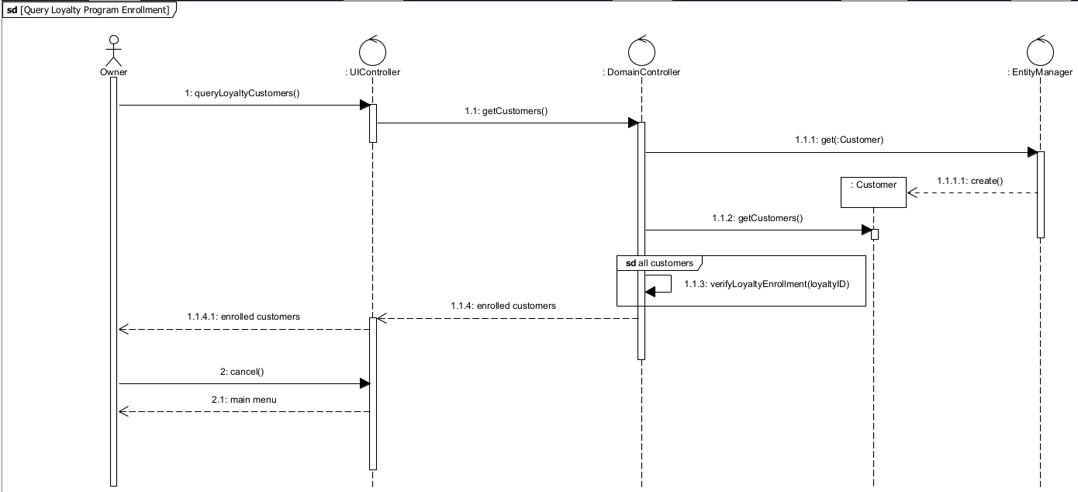

**Voice-Over Script**

**Slides 1-3 {Speaker: Bao-Viet Ho}**

"Good [morning/afternoon/evening], everyone. I'm thrilled to see you all here as we embark on a detailed exploration of our loyalty program implementation.

Our journey today is not just about unveiling what we've developed but understanding the profound impact our work has on customer engagement and satisfaction. I, Bao-Viet will initially set the stage, outlining the broader vision and objectives of our project."

"Directly following, we delve into a critical component of our development process with Ali discussing the user story and its pivotal role. User stories help us empathize with our customers, guiding our design and implementation strategies to align with their real-world needs and expectations. Ali  will underscore the importance of these narratives in creating a loyalty program that isn't just functional but truly resonant with our users."

"Tarandeep  will then take us through the intricacies of our class diagram, revealing how each entity interacts within our loyalty program's ecosystem. This segment promises to shed light on the architectural blueprint of our system, emphasizing the significance of each component in fostering customer loyalty."

"Claudia  will present the first of our sequence diagrams, elucidating the enrollment process within our loyalty program. This visual journey through the enrollment scenario will highlight our system's efficiency and user-friendliness, critical factors in ensuring a positive initial engagement for our customers."

"Building further, Ivan  will explore another sequence diagram, this time focusing on querying customer enrollment. This section will demonstrate our system's capabilities in analyzing and leveraging customer data, a cornerstone in personalizing the user experience and enhancing the effectiveness of our loyalty program."

**Slide 4 {Speaker: -Ali Riza Sevgili}**

Hello and welcome, everyone. Let's dive into the story that is riding our initiative – our Loyalty Program Enrollment. Imagine on foot into a shop wherein you are not just any other customer, but a identified and valued network member. That’s the electricity of a great loyalty program. It’s greater than a gadget; it’s our way of saying to every customer, ‘We see you, we recognize you, and we need you to return returned.’ In the temporary international of father-up shops, in which every purchasing experience is short, our loyalty software works wonders. It turns a brief go to into a long lasting bond, making the memory of our logo closing even after the shop is long past. As we challenge in addition into the arena of brief retail, let's keep in mind that it's all about growing lasting connections."

**Slides 5-6 {Speaker : -Tarandeep Kaur}**

"Hello everyone, I'm Tarandeep Kaur, and I'm excited to guide you through the intricate details of our loyalty program implementation, particularly focusing on our class diagram. Let's delve into it."

 "At the heart of our loyalty program lies the 'Customer' entity, representing the individuals who are enrolled in our program. These customers are the lifeblood of our initiative, and it's crucial to have a clear understanding of their interactions within the program."

"Next up, we have the 'LoyaltyProgram' entity, which serves as the backbone of our entire system. This entity encapsulates all the vital details and rules governing our loyalty program, ensuring that it operates smoothly and efficiently."

"As we move forward, we encounter the 'Purchase' entity, which records the individual transactions made by our valued customers. Each purchase is meticulously logged and associated with a unique 'LoyaltyProgramID,' allowing us to track customer engagement and reward them accordingly."

"Now, let's delve deeper into the significance of maintaining such a structured data model. By organizing our data in this manner, we ensure consistency and accuracy in managing customer information and purchase records."

"This structured approach not only streamlines our internal processes but also enhances the overall customer experience. It enables us to deliver personalized rewards and incentives based on individual customer behaviors and preferences."

"And that's a brief overview of our class diagram and its significance in our loyalty program implementation."

**Slides 7-8 {Speaker: Claudia Suarez}**

Hello everyone. My name is Claudia Suarez, and I'll be explaining the enrollment case scenario. Let's dive into it.

Firstly, our loyalty program offers exclusive benefits and rewards to our valued customers. However, most importantly, capturing customer information and obtaining agreement to terms and conditions is crucial for effective enrollment. It ensures that customers understand the program's rules and allows the company to communicate with them effectively.

For this case, we establish our actor as the customer, and we define some pre and post conditions, as you can see on the table. The precondition is that the customer has accessed the loyalty program enrollment section of the application, and the post condition is that the customer is successfully enrolled and can be queried if required.

In the next slides, we can see the sequence diagram illustrating the interactions between objects involved in the enrollment process of the loyalty program.

The sequence ensures a smooth and user-friendly enrollment process, guiding customers through each step while capturing essential information and ensuring agreement to program terms.

Now, allow me to walk you through the process. When a customer initiates enrollment in the program, the system prompts them to provide necessary information. Upon receiving the information, the system, particularly the DomainController, verifies it and presents the terms and conditions for the customer's agreement. Once the customer agrees, the DomainController generates a unique loyalty ID for the new Customer object, containing their details, and requests confirmation from the customer. After confirmation, the EntityManager saves the customer object, and the UIController sends a confirmation message, redirecting the user to the main menu

**Slides 9-10 {Speaker: Ivan Shandra}**

Hello, my name is Ivan Shandra, and I will be talking about the Use Case for querying customers Loyalty Program enrollment.

 So why is querying this information important? It provides insights into customer participation and engagement, allowing the business owner to analyze customer data, track program effectiveness, and make informed decisions to enhance the loyalty program's performance, which is invaluable for an effective management of loyalty programs, allowing for a higher customer engagement and a more solid customer base. To achieve this, the following Use Case was created. Here, the owner must open the main menu and choose the option to query the customers that are enrolled into a loyalty program. The system then displays a list of enrolled customers with their name, contact information (such as email address and phone number) and loyalty program ID included. Additionally, the owner has the option to cancel the query and return to main menu. The way this works is demonstrated in the following sequence diagram.

The sequence diagram illustrates the interactions between objects involved in querying enrolled customers in the loyalty program, enabling the business owner to efficiently access and analyze customer data related to loyalty program enrollment. Which, as mentioned before, is crucial for informed decision-making, helping to optimize the effectiveness of the loyalty program. As you can see, upon a query request from the owner, the system will fetch the Customer class, get all customers, filter out the customers that are not enrolled in a loyalty program and then return a filtered list of customers with their name, email address, phone number, and loyalty program ID. The logic to cancel the query is also present, which upon the request returns the owner to the main menu.

**Slide 11-12 {Speaker: -Ali Riza Sevgili}**

"Now, allow's talk about the actual benefits our software program brings to the table. We move beyond the fundamental idea of profitable clients. Our loyalty application is crafted to deepen the entire consumer engagement experience. This is set giving customers a strong cause to maintain deciding on us, time after time. And as they do, their delight with our emblem grows, and so does our business – it’s a win-win. Plus, our software's sophisticated data monitoring and evaluation don't simply scratch the surface; they provide us deep insights into what our customers love and the way they behave. This approach we will make smarter choices and shape our marketing in a way that simply speaks to our customers' wants and needs."

"And as we wrap up, I want to extend a huge thanks to all of you. Your engagement with us today is helpful. Sharing our adventure and the insights we've got received with you has been an absolute pride. We’re eager to hear your thoughts, solution any questions, and embrace the chance to discuss how our loyalty software can have a real and wonderful impact to your technique to business and purchaser relationships."